**Overview of experiment:**

You are to conduct an investigation to measure the relationship between the length of an alcohol’s carbon chain and its heat of combustion. The following alcohols will be used in your experiment:

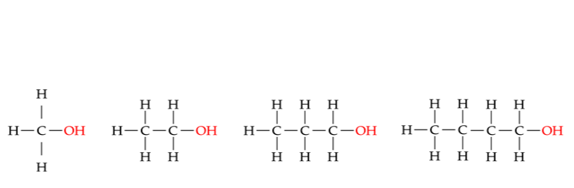

*Methanol Ethanol Propan-1-ol Butan-1-ol*

Information about the heat of combustion can be collected by combusting the alcohol and measuring the amount of heat energy gained by nearby objects. By measuring the amount of alcohol consumed, the amount of energy released *per grams of alcohol* or *per mole of alcohol* can also be calculated.

**Wednesday:**

Each person must show this at the start of Thursday’s lesson to receive 1.5 marks for preparation.

* Plan your experiment.
  + Outline the method that you will follow
  + Do a risk assessment (see template below)
  + Construct a blank results table to record your data into

|  |  |
| --- | --- |
| **What are the risks involved in this experiment?** | **How can these risks be managed to stay safe** |
|  |  |

**Thursday:**

* Collect your data. Submit it to the teacher at the end of the lesson.
* You do *not* need to do your Q=mcΔT calculations Thursday. These will be done on Tuesday week 5.

**Tuesday:**

* You will receive a test paper in which you will need to:
  + Perform calculations using data from your experiment
  + Graph data using an appropriate type of graph
  + Apply concepts of enthalpy to explain changes during the experiment
  + Critically evaluate the reliability of your results and suggest possible improvements
* You will be provided with your results from the previous lesson
* The test will be **open book** as the assessment is primarly testing your *application* of chemistry knowledge

**People wanting to perform well in the test should read over Chapter 10: Scientific Investigations from Nelson (page: 398-418)*.* The test will be open book, but by pre-reading the chapter you will have a rough idea of concepts you may need to refer to during the test. Information here may also be relevant to your exam.**